Year 1 Maths Expectations

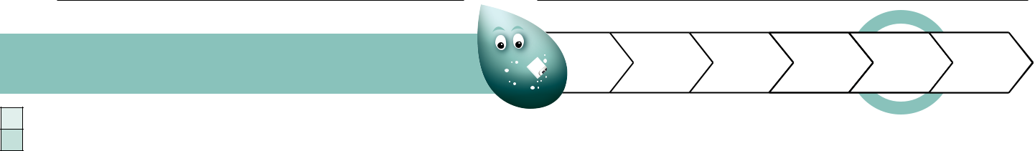

Band 1 - Maths | b | b+ | w w+ | s | s+
Number and Place Value

Count to and across 100, forwards and backwards, beginning with 0 or 1, or from any given number.

I can count to and past 100, forwards and backwards starting from any number.

Count and read numbers to 100 in numerals.

I can count and read numbers to 100 in numerals.

Count and write numbers to 100 in numerals.

I can count and write numbers to 100 in numerals.

Count in multiples of twos, fives and tens from 0.

I can count in jumps of 2, 5 and 10.

Identify one more and one less of a given number.
I can identify one more and one less, given a starting number.

Identify and represent numbers using objects and pictorial representations including the number line, and use the language:
equal to, more than, less than (fewer), most, least.

I can find and show numbers using objects and pictures including number lines and use: equal to, more than, less than (fewer), most, least.

Read and write numbers from 1 to 20 in numerals.

I can read and write numbers from 1 to 20 in numbers.

Read and write numbers from 1 to 20 in words.

I can read and write numbers from 1 to 20 in words.

Count in twos, fives and tens to solve problems e.g. count the number of chairs in a diagram when the chairs are organised in 7 rows of 5 by counting in fives.
I can count in twos, fives and tens to solve problems.

Partition and combine numbers using apparatus if required e.g. partition 76 into tens and ones; combine 6 tens and 4 ones.

I can partition and combine numbers using apparatus if I need it.
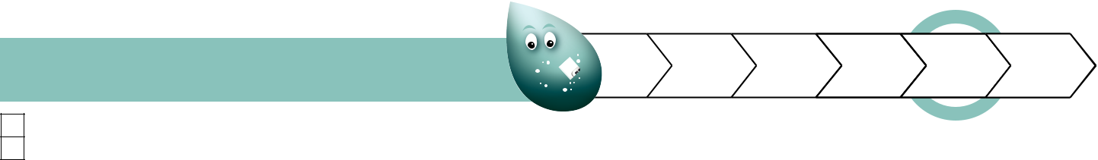

Band 1 - Maths | b | b+ | w w+ | s | s+
Addition and Subtraction

Read and interpret mathematical statements involving addition (+), subtraction (-) and equals (=) signs.

I can read and understand number statements using +, - and =.

Write mathematical statements involving addition (+), subtraction (-) and equals (=) signs.
I can write number statements using +, - and =.

Demonstrate an understanding of the commutative law (e.g. 3 + 2 = 5, therefore 2 + 3 = 5).

I can change calculations to give the same answers, for example 3 + 2 = 5 so 2 + 3 = 5.

Demonstrate an understanding of inverse relationships involving addition and subtraction (e.g. if 3 + 2 = 5, then 5 – 2 = 3).

I can show that addition is the opposite of subtraction, for example if 3 + 2 = 5, then 5 – 2 = 3.

Recall at least four of the six number bonds for 10 and reason about associated facts (e.g. 6 + 4 = 10 , therefore 4 + 6 = 10 and 10 – 6 = 4).

I can remember most of the number bonds for 10 and link the connected facts.

Represent and use number bonds within 20.

I can use number bonds up to 20.

Represent and use subtraction facts within 20.
I can use subtraction facts up to 20.

Add one-digit and two-digit numbers to 20, including zero.

I can add one digit and two digit numbers to 20.

Solve one-step problems that involve addition, subtraction and missing numbers using concrete objects and pictorial representations.

I can answer problems that use addition and subtraction, including missing number problems, using objects and pictures.

Subtract one-digit and two-digit numbers to 20, including zero.

I can subtract one digit and two digit numbers to 20.

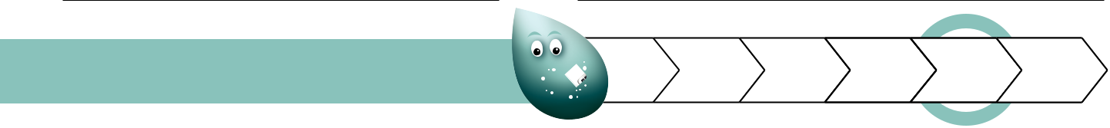

Band 1 - Maths | b | b+ | w w+ | s | s+
Multiplication and Division

Solve one-step problems involving multiplication by calculating the answer using concrete objects, pictorial representations and arrays with the support of the teacher.
I can answer multiplication questions using objects, pictures and other equipment.

Solve one-step problems involving division by calculating the answer using concrete objects, pictorial representations and arrays with the support of the teacher.
I can answer division questions using objects, pictures and other equipment.
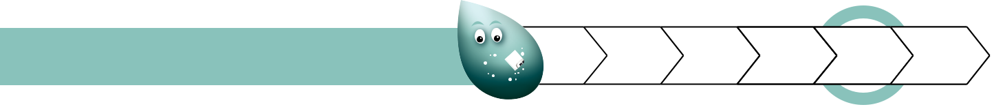

Band 1 - Maths | b | b+ | w w+ | s | s+
Fractions

Recognise, find and name a half as one of two equal parts of an object, shape or quantity.
I can find and name 1/2 (half) of an object, shape or amount.

Recognise, find and name a quarter as one of four equal parts of an object, shape or quantity.
I can find and name 1/4 (quarter) as one of four equal parts of an object, shape or amount.
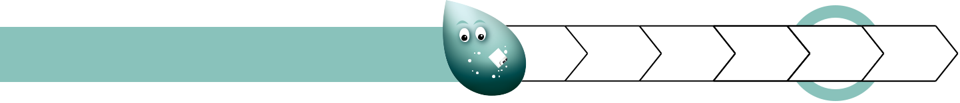

Band 1 - Maths | b | b+ | ww+ | s | s+
Measurement

Compare, describe and solve practical problems for lengths and heights e.g. long/short, longer/shorter, tall/short, double/half.
I can solve problems for length and height by telling which objects are longer or shorter/ taller or shorter.

Compare, describe and solve practical problems for mass/weight e.g. heavy/light, heavier than, lighter than.
I can solve problems for mass and weights by telling which objects are heavier or lighter.

Compare, describe and solve practical problems for capacity and volume e.g. full/empty, more than, less than, half, half full, quarter. I can solve problems for capacity and volume by telling if a container is empty, half full or full and if there is more in
one container than another.

Compare, describe and solve practical problems for time e.g. quicker, slower, earlier, later.
I can solve problems for time. I can tell if something is quicker or slower. I can tell if something happened earlier or later.

Measure and begin to record mass/weight.
I can measure weight or mass and write these measurements down.

Measure and begin to record capacity and volume.
I can measure capacity or volume and write these measurements down.

Measure and begin to record time (hours, minutes, seconds).
I can measure time in hours, seconds or minutes and write these measurements down.

Recognise and know the value of different denominations of coins and notes.
I can tell how much different coins or notes are worth.

Sequence events in chronological order using language e.g. before and after, next, first, today, yesterday, tomorrow, morning, afternoon and evening.
I can tell when things happened by using these words: before, after, next, first, today, yesterday, tomorrow, morning, afternoon, evening.

Recognise and use language relating to dates, including days of the week, weeks, months and years.
I can talk about dates using the days of the week, weeks, months and years.

Tell the time to the hour and half past the hour and draw the hands on a clock face to show these times.

I can tell what the time is in hours and half past the hour. I can draw these on a clock face.

Measure and begin to record length/height.

I can measure and begin to record length/height.

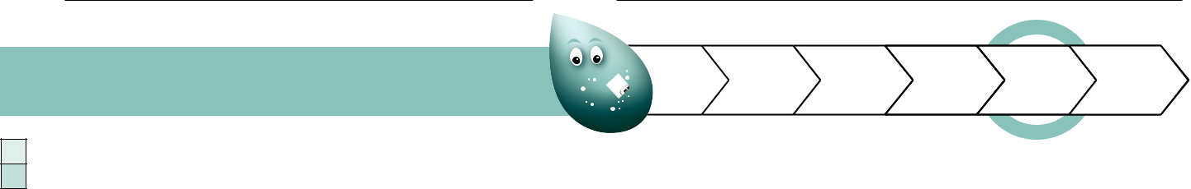

Band 1 - Maths | b | b+ | w w+ | s | s+
Properties of Shape

Recognise and name common 2-D shapes e.g. rectangles (including squares), circles and triangles.

I can recognise and name common 2-D shapes such as rectangles, squares, circles and triangles.

Recognise and name common 3-D shapes e.g. cuboids (including cubes), pyramids and spheres.
I can recognise and name common 3-D shapes such as cuboids, cubes, pyramids and spheres.
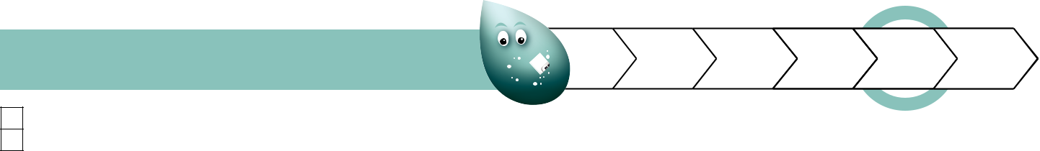

Band 1 - Maths | b | b+ | w w+ | s | s+
Position and Direction

Describe position, direction and movement, including whole, half, quarter and three-quarter turns.

I can talk about whole, half, quarter and three quarter turns. I can then use this to explain movement, direction and position.

