My Toy Dictionary
Name_________
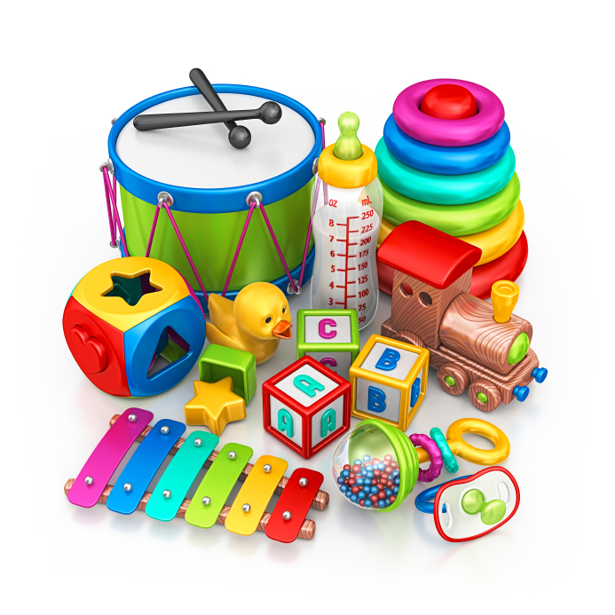
a | b
c | d
e | f
g | h
i | j
k | l
m | n
o | p
q | r
s | t
u | v
w | x
y | z

