

Trimley St Martin Primary School

Updated November 2014

Trimley ST. MARTIN

S.E.F – School Self Evaluation



**SEF:** *Updated Oct 14* 

Trimley St Martin Primary School

www.trimleystmartinprimaryschool.com

Last Updated September 2014

# Summary

|  |  |  |  |  |  |  |  |  |  |  |  |  |  |  |  |  |  |  |  |  |  |  |  |  |  |  |  |  |
| --- | --- | --- | --- | --- | --- | --- | --- | --- | --- | --- | --- | --- | --- | --- | --- | --- | --- | --- | --- | --- | --- | --- | --- | --- | --- | --- | --- | --- |
| **Achievement of Pupils**  2  GOOD | **Strengths** | | | | | | | | | | | | | | | **Areas for development** | | | | | | | | | | | | |
| * **The school has made rapid progress since its last inspection, especially in raising standards and improving teaching. (See HMI letter – June 2014)** * School leaders’ work diligently to make sure high quality teaching and learning is at the heart of everything the school does. As a result, pupils’ achievement is good. | | | | | | | | | | | | | | | 1. Increase the number of children achieving level 6 at KS2 & improve the number of children who exceed expected progress at all levels - **Raise Online Action Plan 3** 2. Increase the number of children achieving level 3 at KS1 (particularly in Writing)   (Use PPMs to focus on Girls and FSMs and ensure that these pupils catch up rapidly and make good progress) - **Raise Online Action Plan 2**   1. Increase the number of children achieving GLD in EYFS - **Raise Online Action Plan 1** 2. Progress and attainment gains have only been stronger over the last 2 years. Continue to improve attainment and progress % | | | | | | | | | | | | |
| **2014 Outcomes** | | | | | | | | | | | | | | | **2015 Prediction** | | | | | | | | | | | | |
| **Phonics** | | | | | | | | | | | | | | | **Phonics** | | | | | | | | | | | | |
| **2012** | 76% | | | **2013** | | | 67% | | | **2014** | | | | 96% | **2015** | 84% | | |  | | | | | | | | |
|  | | | | | | | | | | | | | | | | | | | | | | | | | | | |
| **KS1** | | | **2C+** | | | **2B+** | | **2A+** | | | | **3+** | | | ***KS1***  ***Prediction*** | | | | **2C+** | | **2B+** | | | **2A+** | | | **3+** |
| Rd | | | 93 | | | 89 | | 81 | | | | 30 | | | Rd | | | | 100 | | 100 | | | 76 | | | 41 |
| Wr | | | 89 | | | 89 | | 52 | | | | 15 | | | Wr | | | | 100 | | 79 | | | 62 | | | 17 |
| Ma | | | 96 | | | 89 | | 67 | | | | 22 | | | Ma | | | | 100 | | 100 | | | 79 | | | 24 |
|  | | | | | | | | | | | | | | |  | | | | | | | | | | | | |
| **KS2** | | **APS** | | | **L4+** | | | | **L5+** | | | | **2 lev pr** | | **KS2**  ***Prediction*** | | | **APS** | | **L4+** | | | **L5+** | | | **2 lev pr** | |
| Rd | | 31.6 | | | 100 | | | | 76 | | | | 100 | | Rd | | |  | | 100 | | | 53 | | | 100 | |
| Wr | | 29.9 | | | 95 | | | | 52 | | | | 100 | | Wr | | |  | | 95 | | | 42 | | | 100 | |
| Ma | | 30.4 | | | 95 | | | | 57 | | | | 95 | | Ma | | |  | | 95 | | | 47 | | | 100 | |
| GAPS | | 30.4 | | | 95 | | | | 52 | | | | N/A | | GAPS | | |  | | 95 | | | 42 | | | N/A | |
| **Above National At National** | | | | | | | | | | | | | | | **Above National At National** | | | | | | | | | | | | |
| **Teaching**  2  GOOD | **Strengths** | | | | | | | | | | | | | | | **Areas for development** | | | | | | | | | | | | |
| * Pupils make good progress in their literacy and numeracy skills because teachers teach good lessons. * Next step marking is consistent but progressive throughout the whole school * Teachers have high expectations and there is a whole school drive of constant improvement * Pupils from different groups make good progress because their gaps in learning are addressed through well designed intervention (inc. booster groups). | | | | | | | | | | | | | | | 1. Increase the CONSISTENCY of good and outstanding teaching (focusing particularly in Computing and Science) - **Performance Management Target 1 / SDP Target 1** 2. Ensure above average pupils are CONSTANTLY being challenged and extended - **Performance Management Target 2** 3. Quality of teaching in foundation subjects is not yet consistently good – **Performance Management Target 1** | | | | | | | | | | | | |
| **Behaviour and safety**  2  GOOD | **Strengths** | | | | | | | | | | | | | | | **Areas for Development** | | | | | | | | | | | | |
| * Pupils say they feel safe and enjoy coming to school. They behave well at all times in lessons and around the school. * Parents speak highly of the school and are pleased with the way the school keeps their children safe and happy and the improvement seen over the last few years. | | | | | | | | | | | | | | | 1. Increase the attendance % and ensure individuals, groups with poor attendance are identified and strategies are used to improve their attendance. **SDP Target 5** 2. Continue to develop children's understanding of cyberbullying **ESafety Lead Target** | | | | | | | | | | | | |
| **Attendance** | | | | | | | | | | | | | | | **Target** | | | | | | | | | | | | |
|  | **12 – 13** | | | 95.1% | | | | **13 - 14** | | | | 96.1% | | | | **14 – 15Pre** | | 96.5% | | | | | **County Tg** | | | **95%** | | |
| **Leadership and Management**  2  GOOD | **Strengths** | | | | | | | | | | | | | | | **Areas for Development** | | | | | | | | | | | | |
| * Leadership and management is now stronger, more focused and more dynamic. * The school are leading the way on an initiative to improve G & T provision across the cluster. * Governors monitoring of the school is valuable and the school is challenged by them to make constant improvement. * Leaders responsible for literacy and maths make sure that all teachers plan and deliver lessons that result in good progress being made. * Analysis of data and pupils progress meetings are having a huge impact on pupil progress. * Performance management and pay links have helped improve teaching outcomes. | | | | | | | | | | | | | | | 1. Develop leadership and management of the school (particularly middle leaders and governors) - **SDP Target 2 / Performance Management Target 4a** 2. Introduce and develop an effective new curriculum - **SDP Target 3** 3. Senior Leaders to take more of an active role in assessment, pupil progress meetings and coordinating provision - **Performance Management Target 4b** 4. Improve transition between key stages – **SDP Target 4** | | | | | | | | | | | | |
| **Overall Effectiveness**  2  GOOD | | | | | | | | | | | | | | | | | | | | | | | | | | | | |

**Areas for whole school development**

* Strengthen the middle leaders of the school by: **SDP Priority 2**

– developing the management skills in checking the quality of work in their areas of responsibility and leading improvement

– ensuring that subject leaders support other teachers to improve further the quality of teaching

and pupils’ achievement in all curriculum areas

* Increase the proportion of outstanding teaching and further accelerate pupils’ progress (particularly the higher abilities) in **all** lessons by making sure that: **SDP Priority 1**

− challenge for high ability is evident in all lessons

− more of the most-able pupils consistently learn at a rapid pace by enrichment and application activities.

– pupils are given opportunity to investigate and learn about subjects to a deeper level.

* Continue to build and enhance the School’s new curriculum by: **SDP Priority 3**

− monitoring effectiveness of current topics and look for ways to improve and make more cohesive

− ensuring teachers have the subject knowledge to deliver challenging and inspirational lessons in all curriculum subjects (particularly Science & Computing)

– using feedback effectively to assess how well the topic supports pupil performance

* Bringing the curriculum to life with creative use of resources, visitors and school trips.

**Progress against previous OFSTED key issues**

1. **Raise the quality of teaching to good or better by ensuring all teachers:**

* provide pupils with lesson activities and tasks that are always matched closely to their level of ability
* assess learning during each lesson and adjust their teaching accordingly so that all pupils understand what they have to do next to reach their targets
* do not spend too much time on whole-class teaching and allow pupils to begin independent work more quickly
* insist that pupils work at a brisk pace so they make rapid progress
* have more opportunities to learn from the best examples of teaching across the school and in other schools.

**2. Improve the quality of leadership and management by:**

* making sure that leaders at all levels, particularly subject leaders, check pupils’ progress regularly and accurately to identify possible underachievement and ensure rapid improvement
* helping governors to hold the school more effectively to account by improving their understanding of data on pupils’ performance.

School Evaluation

# Information about this school

This school is a smaller than average-sized primary school.

The new Headteacher joined the school in September 2013.

The proportion of pupils eligible for support through the pupil premium is similar to the national average.

The proportion of disabled pupils and those with special educational needs who are supported at school action is below the national average. The proportion supported at school action plus or with a statement of special educational needs is also below the national average.

The number of pupils from minority ethnic backgrounds and the number of those who speak English as an additional language is lower than the national average.

The school meets the government’s current floor standards, which set the minimum expectations for pupils’ attainment and progress in reading, writing and mathematics.

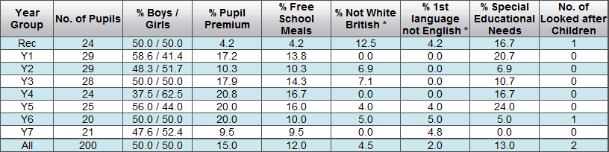

School judgements

|  |
| --- |
| **The achievement of pupils** |

## is good

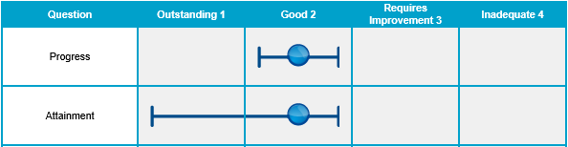

**Progress**

Test results in 2014 show that the percentage of pupils achieving **above average** levels of progress is above the National.

*KS 2 SAT results in 2014 show that the percentage of pupils making expected progress is at least in line with the national average (reading 95%, writing 95% and maths 91%) and those making more than expected progress is above the national average (reading 32%, writing 36% and maths 32%).*

Achievement is good because **all groups of pupils make good progress in reading, writing and mathematics**, given their starting points.

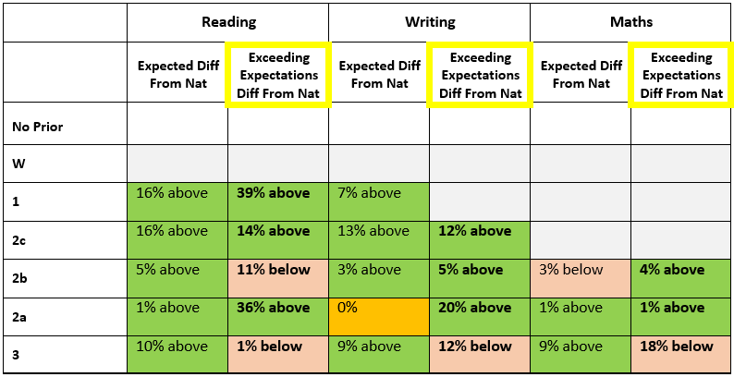

Pupils who speak English as an additional language, disabled pupils and those who have special educational needs make good progress from their low starting points. This is as a result of well planned activities to accelerate their skills in language and mathematics and good quality interventions led by teacher and teaching assistants.

*Pupil Premium*

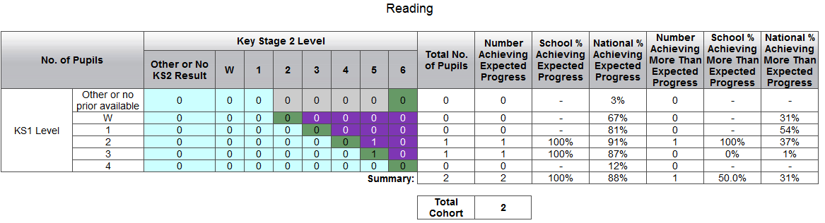

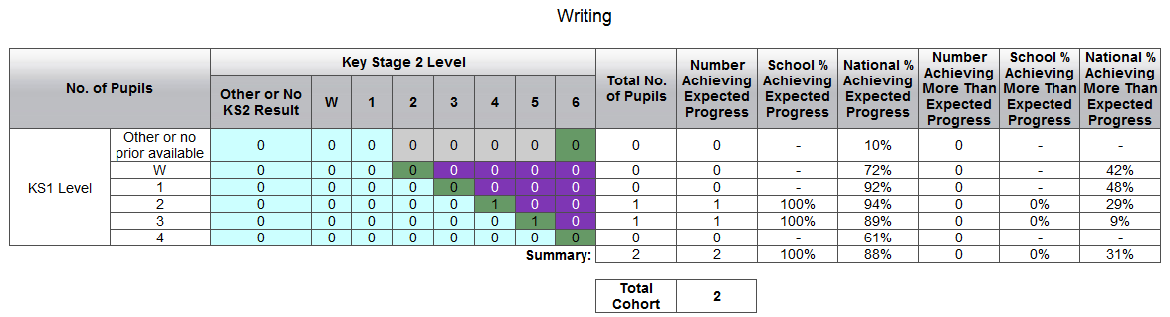

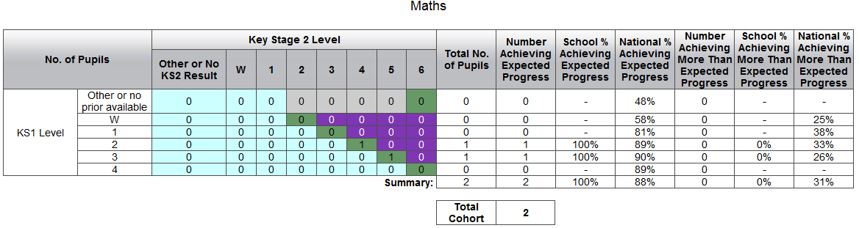

*SEN*

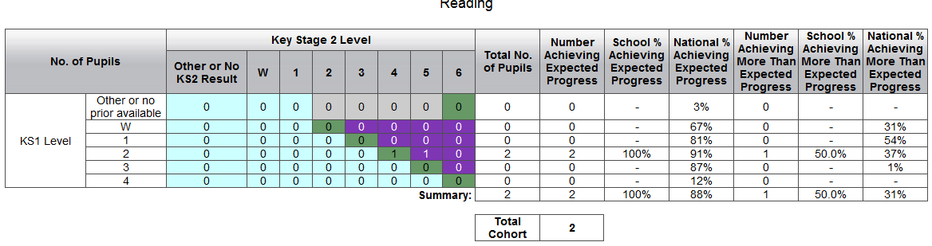

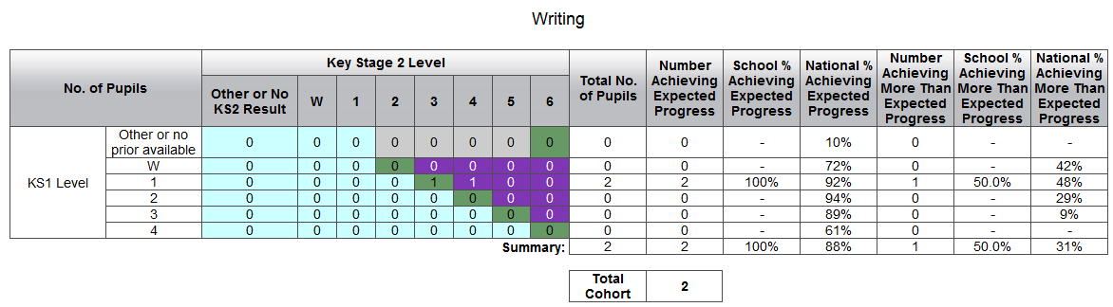

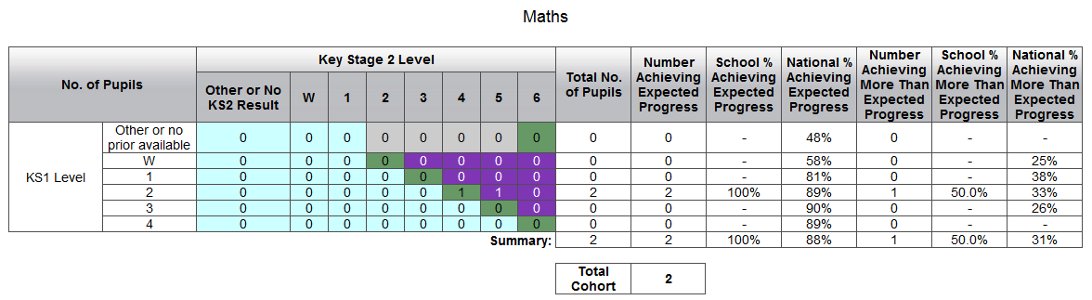

School information on all pupils’ levels show that children are on track to make at least good progress across the key stage 14pts+

**Attainment**

By the end of Key Stage 1, standards are **above average in reading, writing and mathematics**. By the end of Key Stage 2, **the standards attained by pupils are above national levels in reading, writing and maths.**

In Year 1, 96% of children passed the Phonics Test.

*“with at 95% of pupils achieving the expected standard in the check, is a tremendous achievement and points to a high standard of phonics teaching in your school” Nick Gibb MP Minister of State for School Reform*

Pupils eligible for additional funding attain higher standards in reading, writing and mathematics than their classmates and their peers nationally. This is because activities are well matched to pupils’ specific needs through well designed booster groups and interventions.

|  |  |  |  |  |  |  |
| --- | --- | --- | --- | --- | --- | --- |
| **Year Group** | **Reading 4+** | | **Writing 4+** | | **Maths 4+** | |
|  | PP | Non PP | PP | Non PP | PP | Non PP |
| 7 | 100% | 100% | 100% | 100% | 100% | 95% |
| 🡓 Predicted by rolling forward school expectations from current assessment 🡓 | | | | | | |
| 6 | 100% | 94% | 100% | 94% | 100% | 89% |
| 5 | 100% | 90% | 100% | 90% | 100% | 100% |
| 4 | 100% | 95% | 100% | 95% | 100% | 90% |

Pupils enjoy reading and are confident readers. The school uses a range of strategies to promote and encourage regular reading. This raises the level of importance and the profile for reading across the school.

Children join the school in Reception Year, with skills and knowledge that are below the levels expected for their age. By the end of the Early Years Foundation Stage, children make good progress from their starting points. Because starting points for this group were low, despite making good progress the children are only performing at expected level by the end of the reception year. Over the last two comparable years the GLD has been **at or above the national average.**

The school is inclusive and enables all staff and pupils to excel because it maintains high expectations for equal opportunities.

**Achievement Evidence Base**

***Ach.1 Progress***

|  |  |
| --- | --- |
| **Document & Location** | |
| **Points Progress against new school expectations**  % of children making 4pts progress, each year in KS2 (2013) | **Ach1.1** |
| **APS Data**  Points Progress across multiple years Rd, Wr, Ma  APS over last 3 terms  Progress since KS1 (Year 4 and Year 6 exceeding expectations) | **Ach1.1** |
| **TSM Attainment & Progress Summary RAISE 14** | **Ach1.1** |
| **TSM Attainment & Progress Summary RAISE 12** | **Ach1.1** |
| **KS2 Expected Progress (Raise format)**  12 - 13  13 – 14  14 – 15 Predictions | **Ach1.1** |
| KS2 FSM results 12-13, 13-14 & Predictions + Headlines | **Ach1.1** |
| KS2 SEN results 12-13, 13-14 & Predictions + Headlines | **Ach1.1** |
| Example of assessment file evidence | **Ach1.1** |
| Example of new assessment (foundation subjects) | **Ach1.1** |
| **Other documents** | |
| Raise Online 2014 | **RA/SI/OF** |
| Data Dashboard 2013 | **RA/SI/OF** |
|  |  |

***Ach.2 Attainment***

|  |  |
| --- | --- |
| **Document & Location** | |
| SEF Attainment Summary KS2 2012-13 | **Ach1.2** |
| SEF Attainment Summary KS2 2013-14 | **Ach1.2** |
| SEF Attainment Summary KS2 2014-15 Prediction | **Ach1.2** |
| SEF Attainment Summary KS1 2012-13 | **Ach1.2** |
| SEF Attainment Summary KS1 2013-14 | **Ach1.2** |
| SEF Attainment Summary KS1 2014-15 Prediction | **Ach1.2** |
| TSM EYFS data 14 & 3 year trend | **Ach1.2** |
| TSM Phonics Results & 3yr trend | **Ach1.2** |
| TSM KS1 Results & 3yr trend | **Ach1.2** |
| TSM KS2 Assessment Result Summary | **Ach1.2** |
| TSM KS2 Predictions 2015 | **Ach1.2** |
| TSM KS2 Assessment Result Summary | **Ach1.2** |
| School Reading Homework % recording | **Ach1.2** |
| **Other documents** | |
| SIS Document 2014 | **RA/SI/OF** |
| KS1 Development Folder | **KS1 DEV Folder** |
| Year 6 Mark Book (Practise SATs paper results and further assessment) | **Y6 MARK BOOK** |
| EYFS detailed tracking data | **EYFS DATA** |

|  |
| --- |
| **The quality of teaching** |

## is good

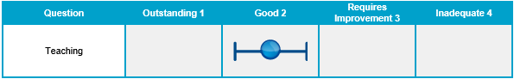

**Teaching**

The quality of teaching is good because teachers provide pupils with positive opportunities for learning and deepening their knowledge. As a result, pupils are happy to come to school and excited about learning. Children make good progress within their lessons.

Standards in reading and writing have improved dramatically. Teachers plan and deliver imaginative lessons that encourage pupils to think and work hard. They adapt lessons to ensure that children are supported and challenged further as a result of good observations and in class assessment.

All groups of pupils including those who are disabled and have special educational needs experience consistently good learning activities. These activities are planned to meet their specific needs and to engage pupils who enjoy developing different skills.

Teachers and their assistants understand how well pupils are doing. They regularly check the progress of pupils to make sure each one reaches their potential. Pupils receive clear feedback in their books on how well they have achieved their targets. Guidance in books does challenge pupils to take responsibility for what they need to do next, and how they can further improve their skills. Regular opportunity is allocated at the start of lessons for children to return to their next steps.

The-most able pupils are often, although not always, provided with challenge in the tasks that are allocated to them. The school are developing the provision for its more able learners by offering a range of different enrichment activities.

Pupils are starting to take responsibility for working on their own and with their peers before seeking help from their teachers.

Children in Reception Year arrive with little knowledge of how to recognise their letters and sounds. The teaching of language, literacy and communication skills is of high quality and ensures that children are learning to sound out letters confidently. Children in Reception Year and Year 1 enjoy their phonics sessions. Pupils are now working on applying their phonics knowledge to their writing.

**Teaching Evidence Base**

***T&L2 - Teaching***

|  |  |
| --- | --- |
| **Document & Location** | |
| Planning Scrutiny | **T&L2.1** |
| Work Scrutiny | **T&L2.1** |
| Pupil Progress Meetings Actions Oct 14 | **T&L2.1** |
| Pupil Progress Meetings Actions July 14 | **T&L2.1** |
| Example of Pupil targets | **T&L2.1** |
| Planning examples | **T&L2.1** |
| Intervention group overviews upto July 14 | **T&L2.1** |
| New marking policy | **T&L2.1** |
| Marking examples | **T&L2.1** |
| Maths homework %s | **T&L2.1** |
| Reading homework %s | **T&L2.1** |
| 1 2 3 Homework | **T&L2.1** |
| Parent Questionnaire April 2014 | **T&L2.1** |
| Pupil Questionnaire April 2014 | **T&L2.1** |
| Pupil Questionnaire November 2014 | **T&L2.1** |
| Parent View UPTO 10th November 2014 | **T&L2.1** |
| **Other documents** | |
| Raise Online 2014 | **RA/SI/OF** |
| Lesson observations & learning walks evidence | **MTL** |
| Lesson observation summary | **L&M** |
| TSM Snap Shot of staff performance | computer |
| Performance letter issued – Anonymised staff member | **L&M** |
| Actions taken to support underperforming staff – anonymised | **L&M** |
| All classes Pupil Progress Meeting minutes, actions & annotations | **Assessment Folder** |

|  |
| --- |
| **The behaviour and safety of pupils** |

## are good

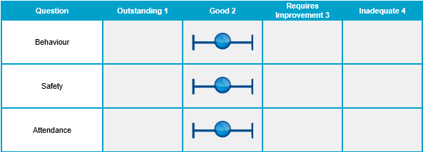

**Behaviour**

The behaviour of pupils is good. Pupils are courteous and welcoming. Their behaviour around the school, at play times and in the lunch hall is consistently good.

Children learn to behave well in Early Years foundation stage (Reception) because routines are established very quickly and they understand what is expected of them. This expectation is consistently reinforced though Key Stage 1 and 2.

Pupils’ attitudes to learning are very positive. In their lessons, pupils listen well to instructions and complete their work to the best of their ability. They help each other and are keen to improve.

Pupils contribute positively to their school through programmes that encourage peer mediation, gardening, enterprise and sports leadership. The student council arranges a number of events. The school nurture group has just produced a giant mosaic during one of their projects.

Pupils do understand what they need to do in order to improve their own learning and they enjoy the challenge of improving and responding to their next steps.

Pupils independence is improving through a range of different initiatives taking place both inside and outside the classroom.

**Safety**

The school’s work to keep pupils safe and secure is good.

Relationships between pupils, their peers and their teachers are very positive. Pupils feel safe in school and are very confident and endearing when talking about their school and their teachers. They have a good understanding of how to keep themselves safe, and they understand potential internet dangers.

**Attendance**

Pupils are very enthusiastic to learn and arrive promptly to lessons. Attendance is above the national average because of the diligent work by senior leaders to improve attendance and maintain good levels of punctuality. This is something the school continues to monitor and promote.

Parents are very positive about the school and feel that their children are safe, happy and educated well.

**Behaviour Evidence Base**

***Beh.1 Behaviour***

|  |  |
| --- | --- |
| **Document & Location** | |
| TSM Values & Vision | **Beh3.1** |
| TSM Behaviour Policy | **Beh 3.1** |
| TSM Parent Questionnaire April 14 | **Beh 3.1** |
| TSM Pupil Questionnaire April 14 | **Beh 3.1** |
| TSM Pupil Questionnaire November 14 | **Beh 3.1** |
| TSM Parent View Questionnaire Nov 14 | **Beh 3.1** |
| **Other documents** | |
| TSM Behaviour log | **Beh &**  **Computer** |
| Lesson observations, learning walks, display around the school / hall | **MTL** |
| TSM Racial Incident Log | **Rac** |
| TSM Incident Record | **Computer** |
| Bullying log | **Computer** |
| TSM Behaviour log | **Beh &**  **Computer** |
| TSM Incident Record | **Computer** |
| Attendance Summary and data | **Att** |

***Beh.2 Safety***

|  |  |
| --- | --- |
| **Document & Location** | |
| TSM Parent Questionnaire | **Beh 3.1** |
| TSM Pupil Questionnaire | **Beh 3.1** |
| TSM Parent View Questionnaire | **Beh 3.1** |
| **Other documents** | |
| E Safety Folder evidence / display and sessions with parents | **ESafe** |

***Beh.3 Attendance***

|  |  |
| --- | --- |
| **Document & Location** | |
|  |  |
| **Other documents** | |
| Attendance Summary and data | **Att** |
| Newsletters – reporting attendance to parents | **Att** |

|  |
| --- |
| **The leadership and management** |

**are good**

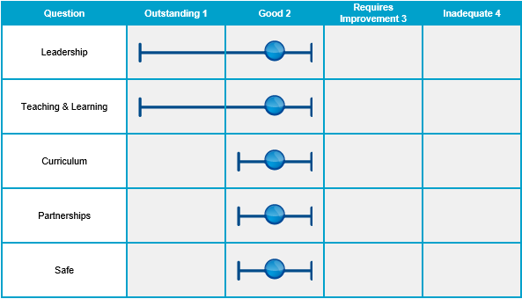

**Leadership**

The leadership team is **driving rapid improvements** and is more effective since the last inspection. This was reflected in a recent visit report from HMI and identified by Suffolk County Council who have rag rated the school as green.

*“Head teacher is leading rapid improvements to the school. Knowledge and enthusiasm is adding drive and impetus to improving the quality of teaching” HMI June 2014*

The Head teacher and Senior Leaders demonstrate strong ambition to move the school to outstanding and their drive is shared by all staff and the governing body.

The governing body supports the head teacher well to ensure that good quality teaching and achievement are maintained. Governors hold the school to account by working closely with the head teacher and senior leaders. They visit the school regularly to keep up to date with developments. Governors take part in regular training on specific courses held by the local authority. They have a good understanding of the school’s information on pupils’ progress and how it is being used to maximise the impact of teaching. On a half termly basis they visit their allocated classes and challenge teachers to raise standards as well as offering additional support. They ensure that teachers are suitably rewarded for good performance related to the quality of their teaching and pupils’ achievement. Additional funding is allocated well and leads to eligible pupils making good progress in their reading, writing and mathematics skills from their starting points. These pupils are **currently doing better** than their peers nationally.

**Teaching & Learning**

Leadership and management reinforce high expectations for all staff and pupils. The head teacher works collaboratively with Assistant Head, Literacy leader and maths leader to ensure that teaching is of good quality and achievement **is at least** good. Leaders model and maintain a calm and positive working ethos throughout the school.

Leadership track teacher performance rigorously and support staff to teach good and outstanding lessons consistently. Underperforming staff have been challenged and supported to improve. Those not reaching that standard have now left.

Middle leaders are being developed and are starting to lead their subject areas and secure the best opportunities for all pupils. They monitor and evaluate their areas of responsibility regularly.

Leaders meticulously analyse how well pupils are doing in their subjects and provide clear, focused next steps for teachers in order to improve areas that need to be worked on. Pupil Progress data is analysed by the Head and the Assessment Leader and along with the class teacher a SMART action plan for addressing areas of concern is put in to place and reviewed half termly. Teaching and achievement are not yet outstanding overall because the high levels currently being achieved by pupils have not yet been sustained. However, predictions for 2015 continue to show the school achieving above national expectations in almost all areas.

Staff use information on pupils’ progress well to inform their teaching. This enables most groups of pupils, including disabled pupils, those with special educational needs, those eligible for the pupil premium and pupils who speak English as an additional language, to achieve well. Senior

Leaders and teachers develop a range of wave 1,2 and 3 interventions and agree targets which need to be met by the end of the half term.

Assessment data is rigorous. The evidence base for the teacher assessment achieved is dated and easily locatable. The school moderates internally on a termly basis and externally at least twice to ensure accuracy and consistency.

**Curriculum**

The subjects pupils learn are well organised by teachers. The New Curriculum is imaginative with some subjects linked by topic and some that are stand alone. Each half term, the curriculum overview includes at least one trip, one visitor to the school and one visitor with a particular profession.

The school arranges regular Curriculum days, in which parents are invited, to continue to raise the profile of subjects other than literacy and maths. In May, the school carried out a Geography day linked to the Commonwealth Games. Individual classes also carry out all day curriculum focused days e.g Design and Technology – Viking Long Boats (Year 6) where outcomes are improved due to the amount of extended time spent on a project.

The school successfully ensures that all elements of spiritual, moral, social and cultural learning are embedded in the daily activities of the school. The school community promotes key values which are directly linked to the names assigned to each of the classes. Pupils take part in community projects and recently regularly raise money for a number of different causes.

The school promotes e-safety. The e-safety lead has introduced a number of initiatives to ensure that children are aware of how to stay safe online.

The school has organised Enrichment and Enjoyment workshop morning for Able, Gifted and Talented not only within the school but within the Felixstowe Area on a Saturday Morning.

**Partnerships**

The school makes effective use of the additional sports funding by promoting physical education and pupils’ health and wellbeing through clubs; both after school and at lunchtimes. Pupils take part in cricket, rounders, cross country running, and tag rugby. They enjoy competing with other pupils and performing their work.

The school has developed strong partnerships with a school outside of the local area to strengthen and improve teaching standards. The local cluster is now also more effective and all teachers within the cluster meet half termly to develop provision for their year groups.

The local authority provides a light support for the school. It has provided opportunities for specialist support when needed and links to outstanding & good schools for collaboration.

**Safeguarding**

Safeguarding practices meet the statutory requirements.

**Leadership Evidence Base**

***L&M.1 Leadership***

|  |  |
| --- | --- |
| **Document & Location** | |
| SWOT | **L&M 4.1** |
| Praise around L & M - HMI Letter / Local Authority Letter / Nick Gibb MP letter | **L&M 4.1** |
| Negotiating timings for next inspection letter | **L&M 4.1** |
| What A Difference A Year Makes – Impact of strategies and improvements 13-14 | **L&M 4.1** |
| FSM Pupil Premium Grant & Timetable of provision | **L&M 4.1** |
| P.E. Premium Grant | **L&M 4.1** |
| Home School Agreement | **L&M 4.1** |
| Full Governing Body Minutes (Oct 14) | **L&M 4.1** |
| Headteacher Report FGB (Oct 14) | **L&M 4.1** |
| Issues from Raise Online 2013 actions & impact | **L&M 4.1** |
| Issues from Raise Online 2014 actions | **L&M 4.1** |
| Moderation of level evidence + subsequent actions | **L&M 4.1** |
| Parent Forum Minutes example | **L&M 4.1** |
| Parent newsletter example | **L&M 4.1** |
| Assessment cycle, subject leader monitoring cycle | **L&M 4.1** |
| SDP 2013 | **L&M 4.1** |
| **Other documents** | |
| Governors Monitoring & Assessment Pack | **Gov** |
| Full Governing Body Minutes | **Min** |
| P.E. Premium & Silver Kite Mark evidence | **P.E** |
| Parent Forum Minutes | **Par** |
| Newsletters | **Par** |
| SEF | **SEF** |
| School Development Plan | **SDP** |
| Governors Signing in sheets | Office |

***L&M.2 Teaching & Learning***

|  |  |
| --- | --- |
| **Document & Location** | |
| Performance Management example | **L&M 4.2** |
| 6 & 12 monthly review PM | **L&M 4.2** |
| Pay recommendations document | **L&M 4.2** |
| Lesson observation Overview | **L&M 4.2** |
| Teaching Assistant PM example | **L&M 4.2** |
| Tackling underperformance – anonymised letter | **L&M 4.2** |
| TSM Snap Shot – anonymised example | **L&M 4.2** |
| Governors Monitoring and Assessment Meetings & Minutes | **L&M 4.2** |
| Pupil Progress Meeting example | **L&M 4.2** |
| Intervention Group overview Autumn Term | **L&M 4.2** |
|  |  |
| **Other documents** | |
| Performance Management records (Teachers & T.A’s) | **PM** |
| TSM Pay Policy and performance standards | **TS** |
| TSM Snap Shot – Recording Teacher Performance | Computer |
| Marking Scrutinies | **WS** |
| Work Scrutinies | **WS** |
| Learning Walks | **MTL** |
| Peer observations / visits to other schools | **MTL** |
| Governors Pupil Perceptions / learning walks | **GOV** |

***L&M.3 Curriculum***

|  |  |
| --- | --- |
| **Document & Location** | |
| Subject Leader monitoring cycle and pack | **L&M 4.3** |
| Long Term Overviews of new curriculum | **L&M 4.3** |
| Half termly overviews | **L&M 4.3** |
| Example of long term / half termly overviews | **L&M 4.3** |
| Curriculum afternoon fliers | **L&M 4.3** |
| Blog print outs of Curriculum activities | **L&M 4.3** |
| **Other documents** | |
| Curriculum Leader Folder | **CUR** |
|  |  |

***L&M.4 Partnerships***

|  |  |
| --- | --- |
| **Document & Location** | |
| Impact of family of schools work 13-14 | **L&M 4.4** |
| Example of action plan from FOS Year 6 Cluster led by TSM | **L&M 4.4** |
| 14-15 Initiatives from Family of Schools | **L&M 4.4** |
| FOS Sports Programme | **L&M 4.4** |
| Enjoyment & Enrichment workshops letter -15th Nov | **L&M 4.4** |
| Family of Schools Website snapshots | **L&M 4.4** |
| **Other documents** | |
| Family of Schools folder | **PYR** |
| Family of Schools Website (Created by TSM) | website |

***L&M.5 Safety***

|  |  |
| --- | --- |
| **Document & Location** | |
|  |  |
| **Other documents** | |
| Single Central Record | **SCR** |
| DBS Data File | **DBS** |
| Safeguarding Course Log | **SAFE** |
| SIMS system | Computer |
| Parents newsletters & safety messages | **Par** |
| TSM New Behaviour Policy | **Beh** |
| Behaviour Recording | **Beh** & Computer |
| Finance committee minutes | **FIN** |

|  |
| --- |
| **Unique reference number** |
| **Local authority**  **Inspection number** |

**School details**

Suffolk

This inspection of the school was carried out under section 5 of the Education Act 2005.

Primary

Maintained

4–11

Mixed

|  |
| --- |
| **Type of school**  **School category**  **Age range of pupils**  **Gender of pupils** |
| **Number of pupils on the school roll** |
| **Appropriate authority**  **Chair** |
| **Headteacher** |
| **Date of previous school inspection** |
| **Telephone number** |
|  |
| **Email address** |

## 185

The governing body

David Kemp

Mr Paul Stock

November 2012

01394 448 313

ht.trimleystmartin.p@talk21.com