Shape Challenge
Competition Time!!
Every challenge completed will receive a small prize.
There will also be a prize for
- Most shapes spotted
- Best location found
Rules are simple
- Look for shapes every whereow many edges does it have? How many
- Talk about shapes- what shape is it? H faces does it have? How may corners?
- Record the places you found them on the record chart
- Hand in by Wednesday 25th May 2016
Vocabulary
Oval- 1 edge Circle- 1 edge
Square- 4 equal edges, 4 corners
Rectangle- 4 edges/ 2 long & 2 short, 4 corners
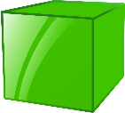 Cube- 12 edges, 8 corners, 6 faces-square shaped
Cuboid- 12 edges, 8 corners, 6 faces- 4 rectangle & 2 square
faces
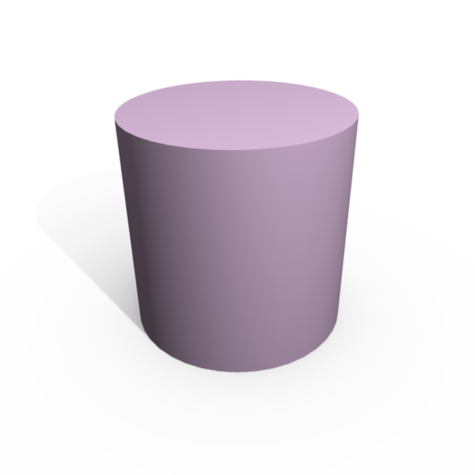
Cylinder- 2 edges, 3 faces
faces

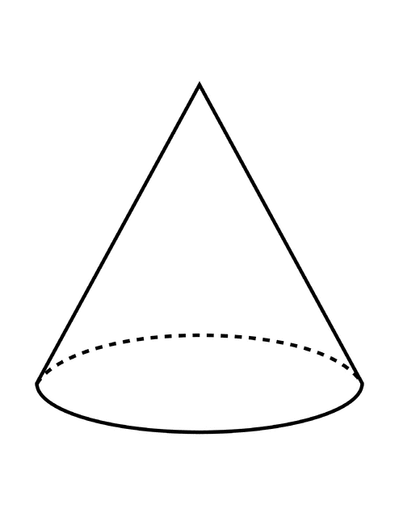
Cone- 1 edge, 2 faces
faces

Sphere- 0 edges, 1 face
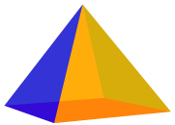
Pyramid- 8 edges, 5 faces, 5 corners
(This pyramid has a square base, some can have triangle bases)

Record Sheet- Name __________________

