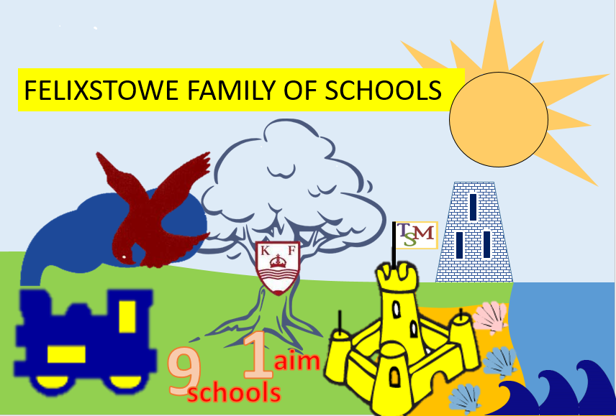
Social Networking Policy

Dear Parents/Guardians,

Due to the rising popularity of social networking sites such as Facebook and Twitter, the staff and governors have agreed that they will be setting a good example to the children in our school, when using these sites.

We would like to invite the parents and guardians of the children in our school to do the same.

This policy tells you what the staff and governors have agreed and what our promises to the children, parents and guardians are when using social network sites. We hope that you will take up our invitation.

The Felixstowe Family of Schools would like to take this opportunity to remind you that if you have any concerns, issues or comments about school, the staff, Headteacher and Governors are available to speak to you.

This policy on social networking is in addition to the School's existing policy on email and internet use or Acceptable Use Policy.

Staff and Parents of The Felixstowe Family of Schools support good practice on Social
Networking Sites

The Headteacher, staff and governors have agreed an approach to the use of Social Networking sites that include the items below. We are now inviting parents to join us in setting a good example for our children.

All parents are invited to join staff in setting a good example for our children by:

- Demonstrating courtesy and respect for staff, other parents and pupils when comments are placed on social networking sites.
- Using appropriate language when discussing school.
- Addressing any issues or concerns regarding school, directly with the Headteacher, member of staff or governors rather than posting them on social media ·

All parents are invited to join staff in setting a good example for our children by not:

- Using social network sites to make derogatory comments or posting photographs which could bring staff into disrepute, including making comments about pupils, parents, other staff members, the senior leadership team, governors, local authority or the wider community.
- Posting photographs of other people’s children on social network sites without their permission.

Our promise to school is:

- We will meet with you and use the Governing Bodies policies and procedures to resolve concerns.
- We will work hard to resolve any concerns in the best interest of the whole community.
- We will act in the best interest of the whole community and honour our duty of care to our children.
- We will never conduct school business through social network sites.

The staff and governors of The Felixstowe Family of Schools agreement for using social networking sites.

All staff agree to
- Not make any reference to their place of work. (Including its name, any activities, or reference to any work related comments)
- Demonstrate courtesy and respect for staff, parents and pupils when comments are placed on social networking sites.
- Ensure appropriate language is used in any comments placed on social network sites.
- Ensure that any comments and/or images could not be deemed as defamatory or in breach of any relevant legislation set out in LA or school policies and handbooks.

- Review and adjust their privacy settings to give them the appropriate level of privacy and confidentiality.

We agree not to:

- Use social network sites to make derogatory comments which could bring staff into disrepute, including making comments about pupils, parents, other staff members, the senior leadership team, governors, local authority or the wider community.
- Use social networking sites to communicate with any pupil or parent in the school.

- Post information or opinions about Trimley St Martin Primary School or pictures of school events.

- Use social networking sites within lesson times (for personal use).

Our promise to parents is:

- We will meet with them and use the Governing Bodies policies and procedures to resolve concerns.
- We will work hard to resolve any concerns in the best interest of the whole community.
- We will act in the best interest of the whole community and honour our duty of care to our pupils. We will never conduct school business through social network sites.

Cyberbullying

The Felixstowe Family of Schools is committed to ensuring that all of its staff, governors parents/carers and pupils are treated with dignity and respect. Bullying and harassment of any kind will not be tolerated. Cyber-bullying methods could include text messages, emails, phone calls, instant messenger services, circulating photos or video clips or by posting comments on web sites, blogs or in chat rooms.

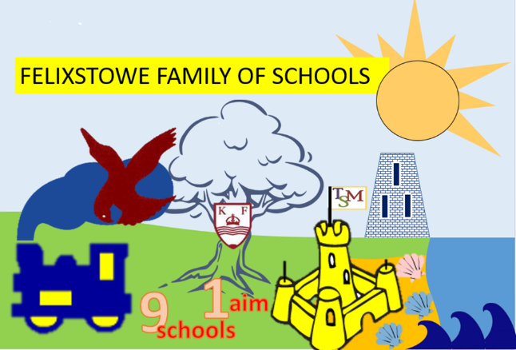

Social Media Declaration

On behalf of the staff and Governors of The Felixstowe Family of Schools: We have read the School’s Social Media Policy and understand the expectations of its staff and governors regarding the use of social media.

Signed on behalf of Trimley St Martin School

Mrs Ross Headteacher

Mrs Painter Chair of Governors

I have read the School’s Social Media Policy and I understand the expectations the school has regarding my behaviour and use of social media.

Name of Child/ren_______________________________________

Parents

_____________________________________ Print Name

_____________________________________ signed ___ /___/____

_____________________________________ Print Name

_____________________________________ signed ___ /___/____

